Thank you very much for agreeing to act as a judge at the Youth and Philanthropy Initiative (YPI) Final Showcase. We hope you enjoy watching the results of the hard work students have put in to the programme.

Your opinions and constructive feedback are much appreciated and will help the students refine their skills. Here you will find a brief description of YPI; some information about the judging process; and a copy of the judging sheet you will be asked to complete for each presentation.

With thanks to our funding partners

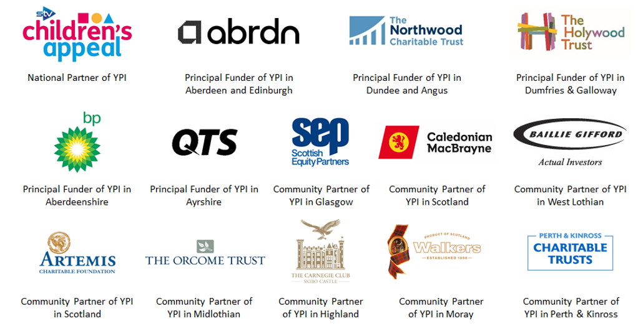

Youth and Philanthropy Initiative
The Youth and Philanthropy Initiative (YPI) is a powerful active citizenship programme, empowering young people to make a difference in their communities while developing a range of skills.

YPI is the biggest independent initiative being delivered in Scottish education. Each school is responsible for directing a grant of £3000 to a local charity championed by its students through a unique programme of teamwork, research, and competition. YPI engages a full year-group of students, developing skills and confidence through a contextualised learning experience. The programme raises awareness of social issues and local charities and is a vital means of devolved, locally driven grant-making. YPI is managed and principally funded by The Wood Foundation. A dedicated team works closely with all participating schools to fully realise the opportunity for their settings. Since it was introduced to Scotland in 2008 by The Wood Foundation, it has engaged more than 230,000 young people who have taken responsibility for more than £5m of charitable giving.

Outline of the Process
One of the strongest attributes of YPI is the flexibility of the programme with respect to delivery timeline, participating year group and academic timetabling. With this in mind, we are not overly prescriptive in terms of how YPI aligns with the broader curriculum, as this is very much dependent upon each individual school context.

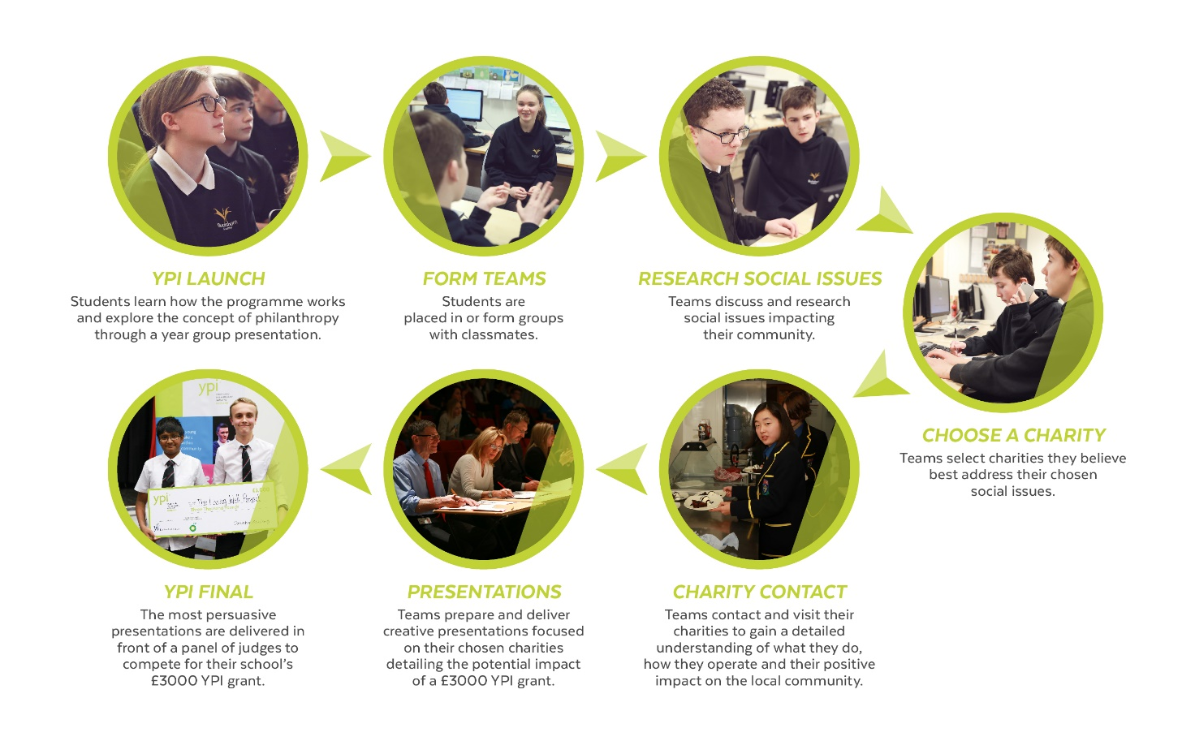

Aims of the YPI Showcase
- To provide students with the opportunity to demonstrate the knowledge and skills they have developed during YPI and to raise awareness of their chosen local charities.
- To give participating students experience of speaking at a high-profile event in front of a large number of people.
- To determine which team of students will be given the opportunity to grant £3000 to their chosen local charity.

Judging Sheet and Criteria
On the next page you will find the YPI Scotland judging sheet. You will be given 1 sheet per finalist team, and these are designed to support you in the judging process by outlining the YPI and Wood Foundation judging criteria. All the represented charities could benefit from a grant, your task is to assess who puts the best case forward for their chosen charity.
The full judging criteria is outlined over page, but here are some criteria to look out for:

Knowledge and Connection – we are looking for students to have made a real connection with their chosen charity. We don’t want YPI to be a classroom-based exercise.
- Did the students meet with the charity or establish meaningful contact with them?
- Is it clear that the team have established a relationship with the charity, beyond conducting online research?

Passion – YPI is an opportunity for students to advocate on behalf of something that they care about. We want to see this passion coming through!
- Were the students able to put forward a convincing, emotive, passionate case for their chosen charity, while relating this to their chosen social issue?

Business Case – By the end of each presentation you should be able to fully understand and appreciate the local impact that the grant will have.
- Is it clear that the students understand where the money will go and who will benefit?
- Did students quantify the impact and clearly explain the difference the grant will make? (e.g. the grant will allow the drop-in session to run an extra 2 nights a week for 6 months, which will have a positive impact on 1500 people)

Creativity – YPI is an opportunity for students to improve their confidence, presentation and team working skills. We want students to have explored innovate and engaging ways to get their message across.
- Is it clear that the students have used their skills both as individuals and as a team to produce a creative and engaging presentation?

Charity name: Social issue addressed:

To be eligible for a YPI grant, a charity must OSCR-registered, positively impact the local community, and provide social services directly to people. Does the charity meet the YPI grant requirements? Yes No Not clear

Note:
Presentations should be between 8-10 minutes in length.
All team members should be actively involved in the presentation in some way.
Videos and other material used in presentations should be original creations by students. Limited use of professional and charity-produced media is permitted, but whether their use was effective will be at the discretion of the judging panel.

 | Very  Effective | Effective | Somewhat Effective | Not  Effective | Not  Present
Knowledge and connection
Connection to and knowledge of the social issue
Knowledge of chosen charity and services provided – positive outcomes for local community
Evidence of engagement with the charity
Passion
Passionate case for why their social issue and charity are important
Explanation of how they were personally impacted by their experience
Explanation of how they have used/will use their skills and/or time to do something helpful
Business case
Clarity on how the £3000 will be used including the LOCAL impact – specific & measurable
Presentation skills and creativity
Effective and well-structured presentation
Creative elements to the presentation
Speaking with clarity and enthusiasm, using eye contact & body language effectively
Overall impressions/notes:

Please don’t hesitate to contact the YPI Team by emailing ypi@thewoodfoundation.org.uk if you have any questions or feedback.

