YPI Checklist
Group Members

Social Issues

Charity



Over the next few weeks your group will research your social issue and charity before creating a presentation to share firstly with your class and then, if successful, with all of S3 in the grand final.

Everyone in your group needs a role:

Role | Responsible

Social issue researcher:
- What is the issue?
- Why did you choose this issue?
- How many people does it affect locally / nationally?
- How does it impact people?
- Do you (anyone in your group) have any personal experience of this issue?

Communications manager:

- Find the contact details for your charity.
- Call the charity to explain what you are doing and ask if they would like to work with you.
- Draft an email, let your teacher read it, and then send it to the charity.
- Arrange an appointment for your group to either visit the charity or have a Teams meeting with them.

Charity specialist:

- What is the name of the charity?
- What is the charity’s OSCR number?
- What do they deal with?
- Where are they based?
- How do they help people?
- How they benefit from a £3000 grant? What would they do with it?
- Work with the Comms Manager to identify questions to ask the charity when you visit them.

Presentation planner:

- How are you going to present your findings?
- What skills do the members of your group have? What style of presentation will you use?
- Collect appropriate images for posters / PPT/ iMovie.
- Write a script.
- Try to be ORIGINAL!

Helpful hints:

Presentation examples: OSCR database link:
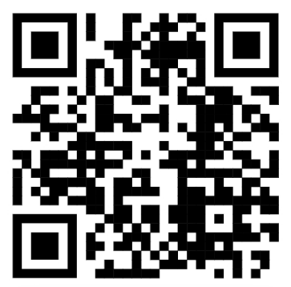
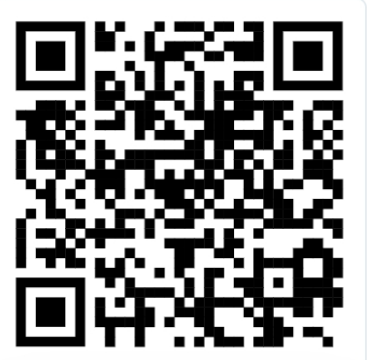
YPI Scotland OSCR | Home

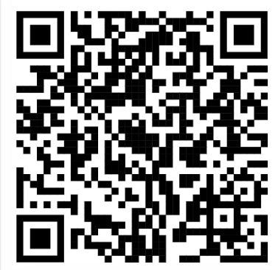
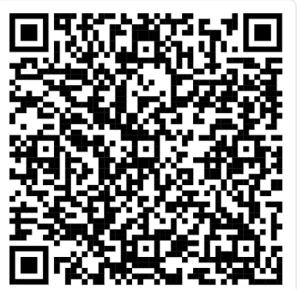
Judging Pack Inspiration zone

YPI_Judging_Pack.pdf Inspiration Zone | YPI

 | What have I achieved each week?
Week | Social issue researcher | Comms Manager | Charity specialist | Presentation Planner
20th October

27th October

3rd November

10th November

17th November

24th November

1st December

8th December

